

Football Rule Changes - (Senior & Minor Football)

The Gaelic Football Rule Changes which become operative on 1 January 2014 are as follows:

- Introduction of a Black Card for Cynical Behaviour Fouls.
- Distinction between Deliberate and Accidental Fouls.
- Definition of the Tackle.
- Introduction of a clearer Advantage Rule.
- A player in possession may score a point with an open-handed hand-pass.

Cynical Behaviour Fouls
- Deliberately pull down an opponent.
- Deliberately trip an opponent with the hand(s), arm, leg or foot.
- Deliberately body collide with an opponent after he has played the ball away or for the purpose of taking him out of a movement of play.
- Threaten or to use abusive or provocative language or gestures to an opponent or a teammate.
- Remonstrate in an aggressive manner with a Match Official.

The penalty for the above fouls are:
- Free Kick from where the foul occurred.
- Order Off offender by showing him a Black Card*.
- Allow a replacement from within the substitutions permitted*.
*Substitutes/Interchange Players
- Maximum of THREE permitted for Black Card Offenders.

Immediate Ordering Off Infractions (Red Cards)
- Striking or attempting to strike with arm, elbow, hand, knee or head.
- Kicking or attempting to kick with minimal force or with force or causing injury.
- Behaving in any way which is dangerous to an opponent.
- Spitting at an opponent.
- Contributing to a melee.
- Stamping.
- Inflicting injury recklessly.
- Abusive language towards a Referee, Umpire, Linesman or Sideline Official.
These are unchanged.
Cautionable Infractions (Yellow Cards)
- To block or attempt to block with the boot when an opponent is kicking the ball from the hand(s).
- To prevent or attempt to prevent an opponent from lifting or kicking the ball off the ground by striking an opponent’s hand, arm, foot or leg with the boot.
- To engage in any other form of rough play.
- To attempt to achieve an advantage by feigning a foul or injury.
The above are all currently existing Yellow Card Infractions.

Noting Infractions
- To hold an opponent with the hand(s).
- To use the fist on or around the body of an opponent for the purpose of dispossessing him of the ball.
- To charge an opponent in the back or to the front.
- To charge an opponent:
- Who is not in possession of the ball, or
- Is in the act of kicking the ball, or
- If both players are not moving in the direction of the ball to play it.
- To charge an opponent for the purpose of giving an advantage to a team-mate.

Noting Infractions remain unchanged – Two Notings result in a Caution (Yellow Card) with a third resulting in an Order Off (second Yellow, followed by Red).

As advised by the GAA in Croke Park the following describes the various scenarios when cards are issued:

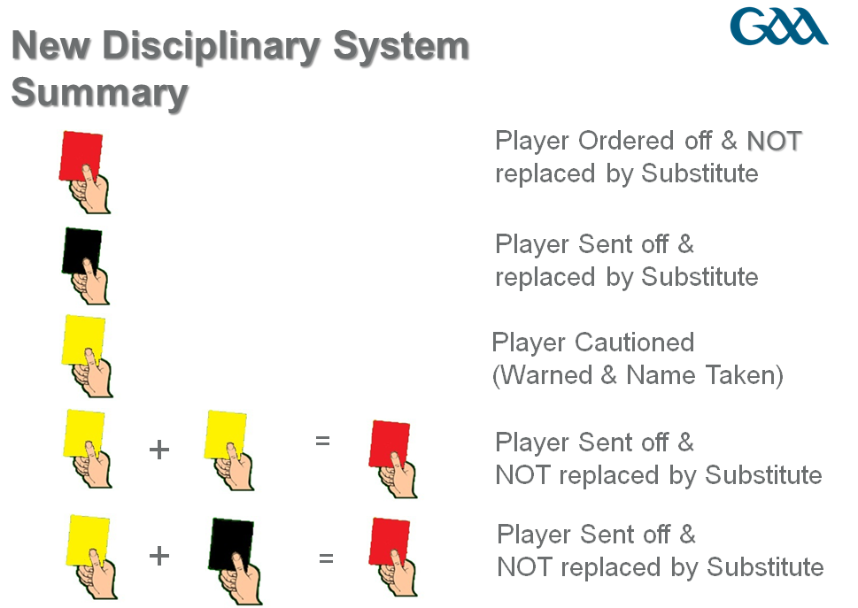

Suspensions
At all levels a Black Card results in a player missing the remainder of the game.

Suspensions
At all levels a Black Card results in a player missing the remainder of the game.

Further suspensions within a State:

2 x Double Yellows within 48 weeks = 1 Game Suspension

Yellow Followed By A Black, Twice Within 48 Weeks = 1 Game Suspension

OR

A Combination of both = 1 Game Suspension

Deliberate v Accidental Fouls
A Card shall be issued only where the Infraction is deemed by the Referee to have been deliberate and not accidental.

The Tackle
The Tackle is re-defined as:
“The Tackle is a skill by which a player may dispossess an opponent or frustrate his objective within the Rules of Fair Play. The tackle is aimed at the ball, not the player. The tackler may use his body to confront the opponent but deliberate bodily contact (such as punching, slapping, arm holding, pushing, tripping, jersey pulling or a full frontal charge) is forbidden. The only deliberate physical contact can be a Fair Charge i.e. Shoulder-to-shoulder with at least one foot on the ground. More than one player can tackle the player in possession.”

Advantage
Advantage Rule is defined as:
“When a foul is committed the referee may allow the play to continue if they consider it to be to the advantage of the offended team. They shall signal that advantage by raising an arm upright. If they deem no advantage to have occurred, they may subsequently award a free for that foul from where it occurred*. The referee shall allow the advantage to run by maintaining their arm in the upright position for up to five seconds after the initial foul or for less time if it becomes clear that no advantage has accrued. They shall apply any relevant disciplinary action.”

Point with Open Hand
A player in possession may score a Point with the open hand or fist.
Questions & Answers:

- The new rules sees the introduction of “Black Card Infractions”, in addition to the existing Yellow and Red Cards? Do we have an actual Black Card.
No, we will be using the Referee’s Black Notebook as the “Black Card”.

- If a player who is Black Carded is being replaced by a substitute/Interchange Player, when may that substitution occur?
At a Break in Play, subject to there being no delay to the game.

- Does the limit of three Black Card subs/Interchange Replacements extend into extra-time?
Yes, the maximum number of subs/interchange allowed for Black Cards is three over the course of a full game, including extra time. To recap; in the course of the game the max number is six, with three more permitted in extra time, the total number of Black Card replacements allowed is three.

- Can a team make six substitutions, even though none of their players has received a Black Card? (When Interchange is not being used)
Yes, the maximum number of subs which a team may use is six; this is not subject to any of them being for Black Cards.

- Six substitiutes have been used by a team, two of them for a Black Card, when a third player receives a Black Card. May he be replaced?
No, the overall limit of six has been reached.

6. During the course of the game which goes into extra time, a team has had four players sent off on Black Cards, three of who have been replaced by a substitute, thus finishing with 14 men, Can this team start extra time with 15?
Yes, Rule 2.6 (d) Part 2 Australasian Rule Book allows a player sent off to be replaced for extra-time and this rule is unchanged. Of course the players dismissed on Black Cards may not play in extra time.

7. A player who has been Yellow carded, and later in the game receives a Black Card and is, therefore, dismissed on a Red; does such a scenario count towards the number of players who may be replaced?
No. three players who receive “straight” Black Cards may be replaced, subject to the total of six subs.

8. What is the penalty, at club level, for a Player who receives a number of Black Cards?
Currently a player is dismissed for receiving a Black Card. He does not suffer any suspension for cumulative Black Cards. However if he receives a second Double Yellow or Yellow + Black within 48 weeks he is liable to a one game suspension.

